## Boston School Forest Digital Herbarium

The Boston School Forest Herbarium was started by a volunteer in 2001, and it has continued through various grant and volunteer efforts throughout the last eight years. It is currently in the final stages of specimen collection covering the 250 plant species that are growing at the Boston School Forest. So far, of the specimens that have been collected, about half have been dried and pressed, and they will be laminated in durable plastic pouches. Meanwhile, data about the plants have been gathered including the identification and verification of the specimens. In addition, research has been completed on the ethnobotany (the scientific study of the traditional knowledge and customs of a people concerning plants and their medical, religious, and other uses) and natural history for the plants.

The Boston School Forest Digital Herbarium will be a tool that can bring the experience of nature to children, either in their classrooms or at home. The collection is a snapshot of what is currently growing on the 80 acres of the Boston School Forest. The digital herbarium will allow children to learn more about the plants they have seen at the school forest should they want to do further exploring, learning, or research.

**Statement of Need**

Every year each elementary-level class takes a field trip to the Boston School Forest. There, they learn about the value nature plays in their lives and about conservation of natural resources. One of the activities they have available to them is the school forest’s herbarium. The herbarium is a collection of all the plants that currently exist at the Boston School Forest; they are preserved by pressing, drying, and laminating them. Children can use it as a reference tool to look up the plants they are able to see and touch while at the school forest. The herbarium can be loaned out to teachers in the Stevens Point Area School District to use in their classrooms for teaching as well.

The Boston School Forest Digital Herbarium will be a technical extension of the current herbarium project and will relieve the problems related to access and unsupervised handling. The access problem is that if the herbarium is out on loan to a classroom, the children visiting the school forest that day will not have access to it. By providing the same content online, the physical herbarium will be able to reside at the Boston School Forest at all times. The other problem is that, although children can be supervised and instructed in the proper handling of its specimens while the herbarium is at the Boston School Forest, if the herbarium were out on loan more children would handle the specimens under the supervision of teacher who may not be as well schooled in preserving these specimens.

Project Goals, Objectives, and Activities

Goals and Objectives

What the Boston School Forest Digital Herbarium will provide is a persistent, easily accessible resource for environmental learning. It will be a searchable, online-accessible database from which students can find and learn about the plants they may have seen or handled during their field trip to the school forest. They will be able to learn the plants' names (common and scientific), where and how these plants grow, and what functions they have in nature and to humans.

Activities

In order to accomplish these objectives it will be necessary to develop the data and infrastructure, which will become the digital herbarium. One of the first tasks will be to make archival quality scans of the preserved plant specimens. These will be very high quality images and will preserve all the details of the specimens. Users should be able to zoom in on the images, just like looking at the real specimens under a magnifying glass. Concurrently, the infrastructure to display this data on the Internet will need to be developed. This will include designing the website where users can access the digital herbarium. Also in this step the interface needs to be developed where users can search the database for the information they require. The final portion of this project is developing the written data about the plants so that the data can be searched in its full text form. This will require encoding it in eXtensible Markup Language (XML). In the end these three projects will be combined, and the Boston School Forest Digital Herbarium will be ready for people to use.

Currently we are preparing the gathered plants by laminating them to ensure that the specimens will be protected. This will allow the specimens to be scanned without damaging them.

Each laminated specimen will be placed on a flatbed scanner and a digital image will be created. The scanning will be done by volunteers or unpaid interns, if at all possible. The images taken from the scanner directly will be the master archive files and will be stored in uncompressed TIFF format. These archive files will be of high quality to comply with current digitization standards, each scanned in at 300 dpi (dots per inch) and in 24-bit color.

From the master archive file a number of smaller derivatives will be created. These derivatives will serve as thumbnails (200 pixels on the long edge), screen-level images (800 pixels on the long edge), and full-size images (depending on the size of the original specimen, approximately 3,000 pixels on the long edge for a 10-inch specimen). The derivatives will be compressed JPEG files and will have smaller dimensions. The decrease in quality of the derivatives will be minor and the size of the files will be much smaller, making them appropriate for web delivery. All derivatives will be generated using ImageMagick, free and open software that allows for the resizing and converting of image file formats in large batches.

The larger JPEG files will be available on the web page via Zoomify, an image viewer that allows the user to pan and zoom to specific portions of the image. Given that this technology requires some additional software packages (including a Macromedia Flash plugin for the web browser), links to the images in standard JPEG format will also be available on the page.

A metadata specialist will then generate the appropriate metadata fields to describe the scientific classification, collector of the specimen, where and when it was collected, and so forth. This metadata will allow for a variety of facets to be searched, including some that are more specific to enthnobotany, including the species niche in the ecosystem and possible and historical uses to humans (as medicine, food, etc.). In addition to the descriptive metadata about the specific specimens, metadata will be utilized to encapsulate all of the files into a singular digital artifact. If multiple specimens are available for a single species, the additional images will be available as separate links on the search results page.

The total size of the collection, archive files, derivatives, and metadata encapsulation will be approximately 5 GB.

Once the digitization project is complete the Herbarium Coordinator will prepare a teacher in-service activity. It will be a learning opportunity for teachers in the Stevens Point Area School district to learn about using the digital herbarium as teaching resource in their classrooms. There will be example activities, which teachers could incorporate while yet in their classrooms prior to and after the class’s field trip to the school forest. These activities will provide an enriching, more interactive experience for children when they actually encounter the plants they learned about at the Boston School Forest.

Dissemination

Intellectual Access

Intellectual access to the Digital Herbarium will be provided by a trained metadata specialist, possibly a student intern from a local library school, who will use information about the plants to create a Metadata Encoding and Transmission Standard (METS) record. METS is designed to encode descriptive, administrative, and structural metadata about a digital object in a single XML file. We find that the interoperability of METS with other common metadata schemata, including Dublin Core and the Text Encoding Initiative (TEI), make this an ideal method of disseminating metadata.

Specific information about the flora within the database will be identified within the METS record using the Darwin Core[1] schema. Darwin Core is a metadata schema designed specifically to describe living organisms and their habitats. Because this schema is often used in digital collections to classify information about plant species, it is an ideal specification for the plants found within the Boston School Forest. For intellectual aspects of the collection that cannot be elegantly represented by elements of the Darwin Core schema (such as the toxicity and human usage of a species), a set of custom elements will be created using the Resource Description Framework (RDF) to be employed within the METS record. Specimen information sheets, found on the back side of each physical sample scanned into the collection, will be encoded in TEI for searchability. The final METS records will be shared with other libraries and the general public using the OAIster service.

Finding Aids

The final website and database will contain a tutorial for creating effective searches within the database. As we realize that this digital project was primarily created for educators and their students, we will work to customize the database search tutorial for this audience using general language. This document is important because the search engine will contain full Boolean search capabilities, a technique with which students using the database may not be familiar. Although we anticipate that full Boolean capabilities will primarily be used by librarians and other expert searchers, we want the tutorial document to be available for students so that they may reference it if they cannot find what they are searching for.

Another finding aid that may be of use is an index of flora found within the database by common and scientific names. This cross-referencing tool for browsing, which would contain mini queries within to find items of that specific type, would be useful for those who want to go directly to a specific species but are unsure what name it is indexed under in the database. It will also be useful for teaching students the plants' scientific names. The website will also contain the ability to browse the collection by usage, toxicity, and other parameters.

Web Design

The design of the website and database interface will require the implementation of many web technologies. We plan to utilize a combination of XHTML, PHP, and MySQL to handle basic web delivery of content. Additional technologies, such as Zoomify for specimen image panning and zooming, will be used to enhance and support the delivery of content found within the database.

In addition to a simple search, we want to provide advanced search functions for users to take advantage of. The advanced search page (see Figure 1) will house these more complex functions. We want users to be able to broaden their search to the full-text records of the entire collection for a single string, or to narrow the search to a single metadata field. We also wanted to allow users to be able to browse by selecting a combination of plant part and human use, (e.g., having edible roots). This will be done with a pair of drop-down boxes: one for the plant part, and one for the human use. Additional fields for both the advanced search and human uses can also be created on demand from the user. After performing a search, the user will be presented with the search results screen (see Figure 2). This screen lists the hits in a table showing a thumbnail image, scientific name, and common name(s). Clicking any of these will bring the user to the species view.

The species view (see Figure 3) will be the most detailed view of a specimen. Metadata about the plant’s scientific and common names, habitat, description, human uses, ecological niche, and discriminating characteristics will all be presented. A small Zoomify window will be used to allow the user to interact (panning around the image, zooming in and out) with the highest resolution images with minimal bandwidth overhead. In addition to this small window, there will also be the option to view a full-screen Zoomify window. The user will also have the option to view several sizes of static JPEG images.

Project Evaluation

Website Evaluation

The website will be completed simultaneously with the evaluation phase so that the designer may be advised throughout all phases of the development of the database. In evaluating the site, we will work with groups of users (namely the local students and teachers and members of the general public) to gather data and interpret the effectiveness of the module and ease of use across different types of users. When the Stevens Point Area School District's science teachers meet to discuss their Environmental Education curriculum, we will present the Digital Herbariums web interface for their evaluation. We will analyze their feedback and incorporate their suggestions into the final version of the search interface. Focus groups and surveys may be conducted (both before and after the initial version of the site has become available to users). Server logs are a good quantitative tool for evaluating website usage, and we intend to analyze them to understand how users are finding the site, what pages they are viewing, and other useful information. Continuous evaluation during the development of the project and after it has been completed will ensure that the digital herbarium is relevant and easy to use, and it will help to pinpoint any areas in which the project may be improved.

Staff Qualifications/Management/Personnel

Metadata Specialist

We will need to hire a specialist who can work on a temporary basis to put the metadata records together with the images and interface. He/she should possess the following skills: at least 1 year of experience working with metadata records of various types (including METS and Dublin Core) in a library or archival/records management environment; some experience with, or at least a desire to learn, TEI; and Library Science or Archival Science coursework. The opportunity could be a good internship for a School of Library and Information Studies student at UW-Madison.

Staff Members Already Identified

* *Sue Anderson, Herbarium Coordinator and BSF Staff:* Scan herbarium originals, encode herbarium backpages into TEI, teacher inservice/final report
* *Graham Dostal, Digital Librarian:* Design interface and infrastructure for digital library web page
* *Karen Dostal, BSF Director/Project Administrator:* Project administration/teacher inservice

Continuation

Preservation of Project Files and Maintenance of Delivery Interface

Once initial funding for the digital herbarium project has come to an end, steps taken to preserve and maintain project files for the long term will help to ensure the sustainability of the collection. The Boston School Forest's Digital Herbarium will be preserved and maintained by the school district, to allow for enjoyment and education of current and future students. The staff members responsible for scanning the specimens, creating the metadata for them, and making them available through the online module will take measures to store the files in a centrally managed system (such as a high-capacity network server) maintained by the school district's information technology department. Storage on this server will ensure easy access for the staff members working to improve and maintain the project over time. Archive copies of all the digital specimens will be stored on archival quality gold DVD-Rs in case of a disaster or similar situation in which master back-up copies would have to be accessed to keep the digital herbarium up and running.

We will take certain practical measures while planning and developing the digital herbarium to ensure the sustainability of the project over time. The project will involve the use of international image format and metadata standards as well as standard approaches to digital collection development and maintenance to ensure the interoperability of components for long-term use. The web design will match that of the existing Boston School Forest website, and it will be flexible and accommodating to allow for easy maintenance and posting of additional of resources without staff having to overhaul the system. The staff members involved in the project will carefully document their work on all aspects of the project (standards, formats, and techniques used in the process) so that future staff members may have guidance as to how to maintain the project.

Funding the Project for the Long Term

Financially speaking, the continuation of the digital herbarium after initial grant funding has ceased will be possible by a combination of funding from two sources. First, we intend to support the project as a long-term investment. Preservation of the files and maintenance of the project should prove to be inexpensive and can be funded by the school's annual budget. Secondly, the school will seek additional funds from granting agencies as they become necessary. The Boston School Forest Digital Herbarium will be a valuable and impressive resource that will no doubt gain the attention and support of funding bodies as its relevancy and importance to the school and greater community become ever more apparent.

As the habitats change here at the school forest, so will the forest's ecology. That is, different species will move into and out of the 80 acres comprising the school forest. We will therefore need to continually update the database with newly arrived and newly discovered species. By utilizing the expertise of the school forest's staff in the initial creation of the digital herbarium, we can continue its development with minimal expense.

|  |  |  |  |
| --- | --- | --- | --- |
| Administering Organization: Stevens Point Area Public Schools, Boston School Forest | Project Director: Karen Dostal |  | Telephone: (715) 345-7383 |
| Budget Category | Grant Request | Match | Match Type (i.e. monetary, service, or supplies) & Source |
| **Salary/Honoraria**   |  |  |  | | --- | --- | --- | | (Name or position) | (Rate & time period) | (Activity) | | Sue Anderson, Herbarium Coordinator | 15 hrs. @ $15/hr. | Scanning herbarium originals | | Graham Dostal, Digital Librarian | 3 hrs. @ $18/hr. | Designing webpage for digital library | | Graham Dostal, Digital Librarian | 32 hrs. @ $30/hr. | Designing search interface and digital library infrastructure | | Sue Anderson, Herbarium Coordinator | 64 hrs. @ $15/hr. | Encoding the herbarium backpages into TEI | | Karen Dostal, BSF Director/ Project Administrator | 15 hrs. @ $19/hr. | Project administration/ Teacher inservice | | Sue Anderson, BSF Staff | 8 hrs. @ $15/hr. | Teacher inservice/ Final report | | $54.00  $960.00  $120.00 | $255.00  $960.00  $285.00 | Stevens Point Area Public Schools (service)  Stevens Point Area Public Schools (Service)  Stevens Point Area Public Schools (Service) |
| Fringe Benefits |  |  |  |
| Travel (mileage, lodging, meals) |  |  |  |
| Materials/Supplies (Be specific. Identify & quantify items and cost per item.)   |  |  | | --- | --- | | **Capital Item:** | **Activity:** | | 1 Epson Perfection V700 Photo Scanner | Scanning Herbarium | |  |  |  |
| Other |  |  |  |
| Total | $1613.99 | $1500.00 |  |

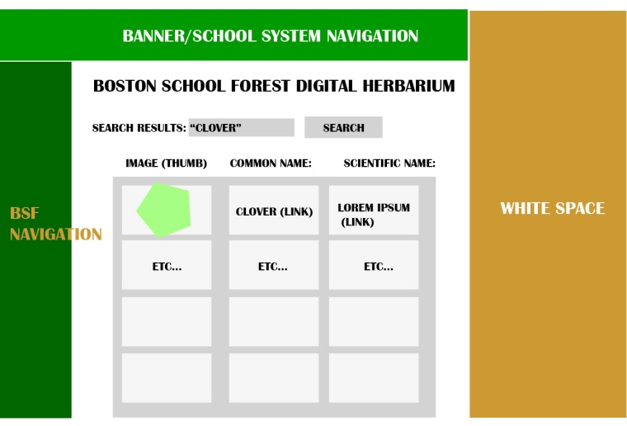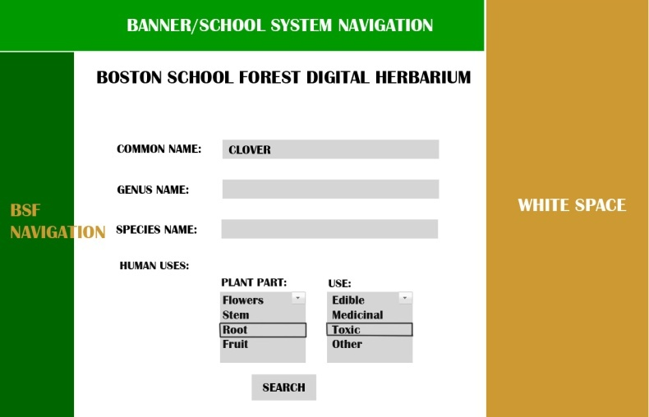Wireframes

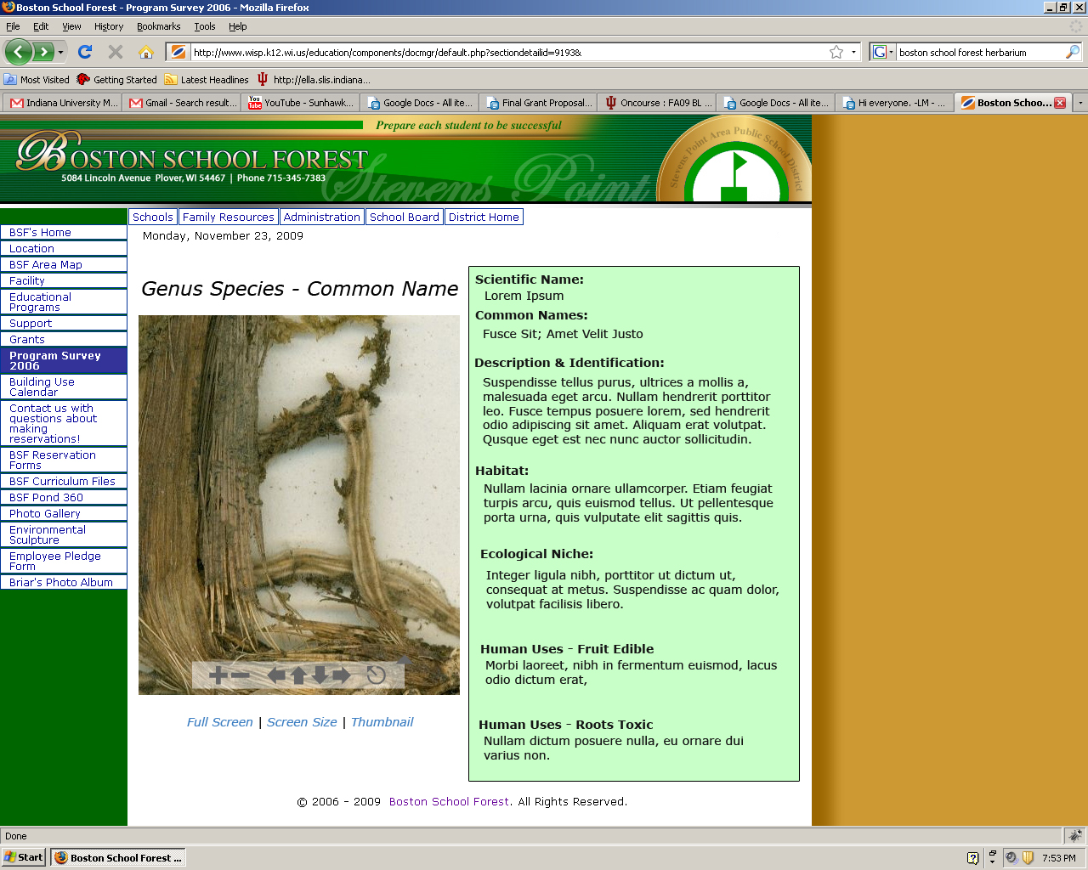

Figure 3. Specimens Mock-up

Figure 2. Results Level

Figure 1. Search Level

1. http://wiki.tdwg.org/twiki/bin/view/DarwinCore/DesignAndPurpose